Family Now 3.5
UNISYS
Detailed Design- Provider Overview

Version 1.0 Status: Approved
6 09 2017

Unisys Confidential
This document is confidential and proprietary to Unisys Corporation. It is not to be used, reproduced, or disclosed outside Unisys without the written consent of Unisys Corporation. The information in this document is furnished for use by Unisys support personnel in servicing customer’s equipment, or by a customer under a license agreement with Unisys.

Document Revision History

Date | Version | Section Changed | Change Description | Author | Reviewer | Approver
1 Sep 2017 | 0.1 | All | Change the flow | Vibhav Dwivedi | Mark
6 Sep 2017 | 1.0 | All | New Document | Vibhav Dwivedi | Mark

User Story #67: Provider Overview

USER STORY: As a Provider user, I want to be able to access the overview screen of a given provider from the My Organizer screen.

1. Screen: CPS –Maltreatment

  - STATIC CONTENT:
- App Name (Logo): Family Now
- Visual screen elements
- Screen Title: Maltreatment
- Trigger action: My Organizer - > My Provider applet
- Select ‘Provider’ from drop down and click ‘Refresh’ button
- Click on ‘View All Providers’ link
- In Provider Information Screen, click on ‘Provider ID’ hyperlink of any provider

  - SCREEN SHOT
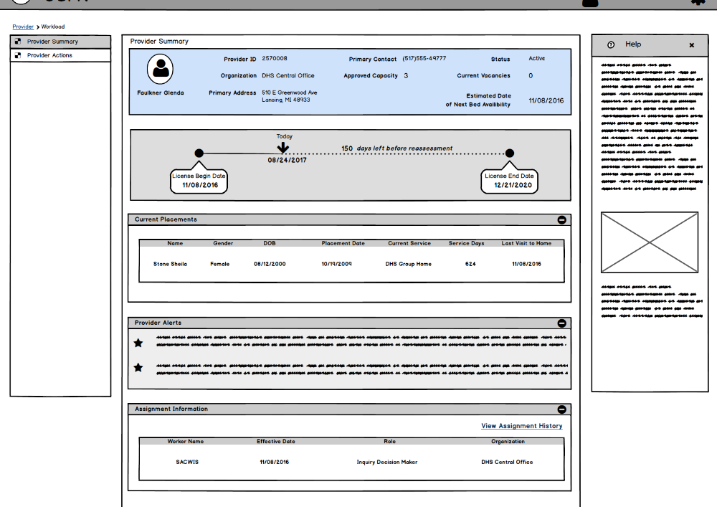

1.4 ACCEPTANCE CRITERIA

# | UC/Screen/BR | Requirement | Status
1 | Provider Overview screen | The person in the header of the provider should be able to have their photo uploaded to the person record and appear in the header. | Approved

